The Nature of Resistance

Teacher Guide

|  |  |  |
| --- | --- | --- |
| Authors: |  | Jim Overhiser and Julie Nucci |
|  |  |  |
| Original:  Recent Update: |  | 7 August, 2008 October 2007  15 May, 2015 |
|  |  |  |
| Level: |  | Regents and AP Physics |
|  |  |  |
| Abstract: |  | Students perform a series of guided activities that illustrate how microscopic and macroscopic features of metals relate to resistance and current flow. Activities include: thermal  considerations of resistance, electron drift under an applied voltage, the effect of defects on resistivity, and the effect of length and cross-sectional area on resistance. |
|  |  |  |
| Time Required |  | Three 40-minute class periods |
|  |  |  |
| NY Standards Met: |  | * Energy may be stored in electric or magnetic fields. This energy may be transferred through conductors or spaces and may be converted to other forms of energy. (4.1j) * All materials display a range of conductivity. At constant temperature, common metallic conductors obey Ohm’s Law. (4.1l) * The factors affecting resistance in a conductor are length, cross-sectional area, temperature and resistivity. (4.1m) |
|  |  |  |
| Special Notes: |  | This activity assumes knowledge of atomic bonding, Ohm’s Law and conceptual definitions of current, resistance, and voltage. |

This lab is made available to Purdue University Science Express

by collaboration with Cornell University, Ithaca, NY.

**Learning Objectives:**

Upon completion of this lab activity, students should be able to:

* Describe and explain the factors that influence the resistance of a conductor including: thermal effects, material defects, length of the conductor, and cross- sectional area of the conductor.
* Accurately explain how electrons move in a conductor.

**Class Time Required:**

Approximately 120 minutes for the lab activities in addition to introductory discussion

**Teacher Preparation time:**

Minimal; setting out the materials and background reading.

* Check all meters and batteries prior to lab
* Study material explaining the influence of defects on resistivity

**Assumed Prior Knowledge of Students:**

* Ohm’s Law
* Conceptual definitions of: voltage, current, charge, metallic bonding, atoms, electrons
* Familiarity with the concept of a vector as the sum of a combination of forces
* Familiarity with the use of a multimeter

**Overview of Activities:**

1. Pre-lab. Students define terms and identify concepts important to understanding electrical conduction on an atomic level.
2. Electron motion in metals

* Thermal motion: Using a pencil and paper activity, students explore the thermal behavior of electrons in a conductor on an atomic level.
* Heat and resistance: Students perform an activity to illustrate the effect of temperature on resistance (via its effect on the resistivity).
* Voltage and electron drift: Using a pencil and paper activity, students examine how electrons drift when a voltage is applied to a metal.

1. Defect Effects

* Atomic BBs: Students use BBs to model the arrangement of atoms in a polycrystalline metal. The concept of crystallographic defects as a source of residual resistivity will be introduced. The main defects discussed are vacancies and grain boundaries.
* Grain boundaries: Using a pen and paper activity, students examine the effect of grain boundaries on electron drift in a metal under an applied voltage.

1. Play-Doh™ Resistor: Students use Play-Doh™ to measure the effect of conductor shape on resistance.

**Equipment List**

12

6

6

1

7 8

7

8

2

3 13

4 9 10

9

11

5

**Material List**

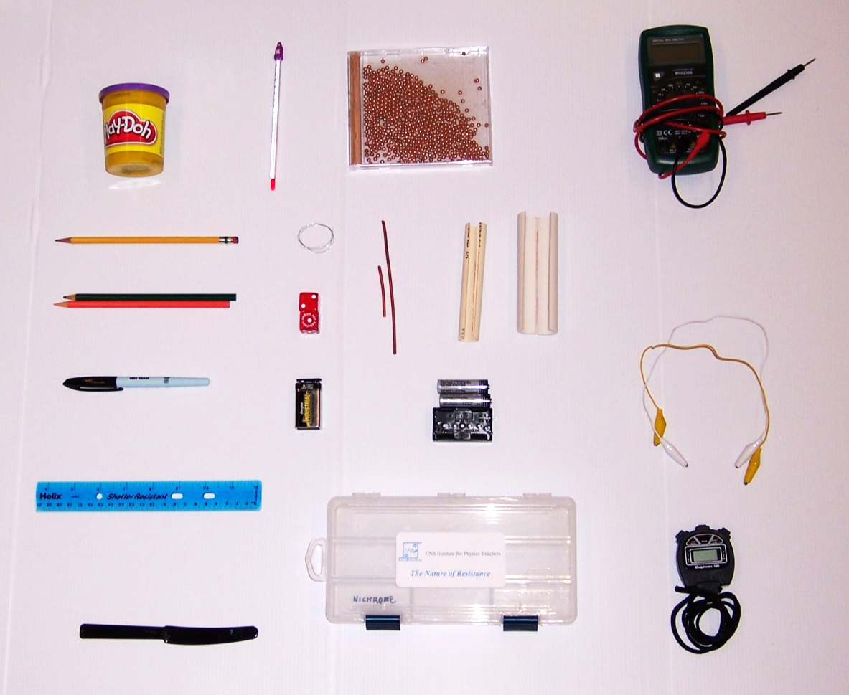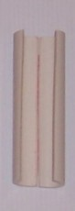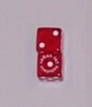

|  |  |  |
| --- | --- | --- |
| **Item No.** | **Quantity** | **Item** |
| 1 | 1 | Play-Doh™ |
| 2 | 1 | pencil |
| 3 | 2 | colored pencils |
| 4 | 1 | plastic knife |
| 5 | 1 | ruler |
| 6 | 1 | CD case with BBs |
| 7 | 2 | pieces of metal rod |
| 8 | 1 | 3/4” Play-Doh™ resistor form |
| 9 | 1 | 9-volt battery |
| 10 | 2 | dice |
| 11 | 1 | kit box |
| 12 | 1 | multimeter |
| 13 | 3 | alligator clips |
| Not shown | 1 | Graph paper |

**Teaching Tips:**

1. In Part III, exposure to air and current dries out the Play-Doh™ , which will adversely affect your measurements. Minimize the time Play-Doh™ is out of the container to keep it moist..
2. When taking electrical measurements, take as little time as possible between measurements. Have students immediately disconnect the circuit after taking each data point.
3. Student unfamiliar with the use of multimeters will be confused as to which leads go where and the difference in making measurements of voltage and current. Have them practice with the meter and explain the different settings, if necessary with a diagram.

**Connection Diagram**

